**Exercise**

1. **I was required to return all the products their name, unit price and new price with 10% increase.**

**SQL query**

SELECT

name,

unit_price,

unit_price * 1.1 AS "new price"

FROM products

**Output**

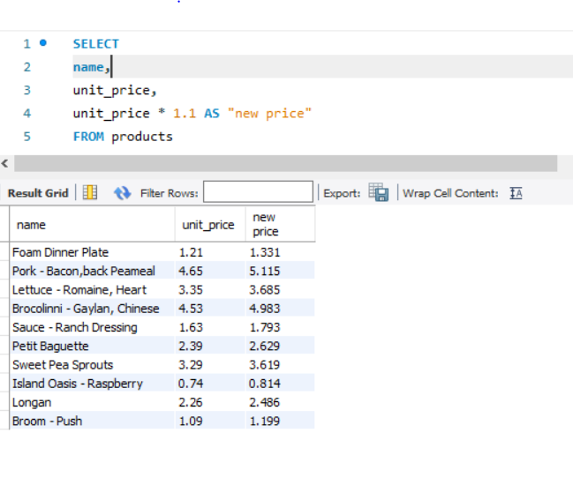

1. Looking for orders that were done in 2019

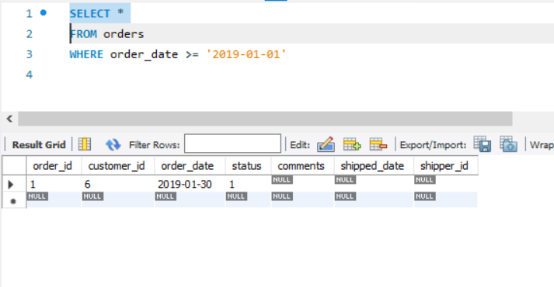

1. From the order-items table, get the items for order #6 where the total price is greater than 30.

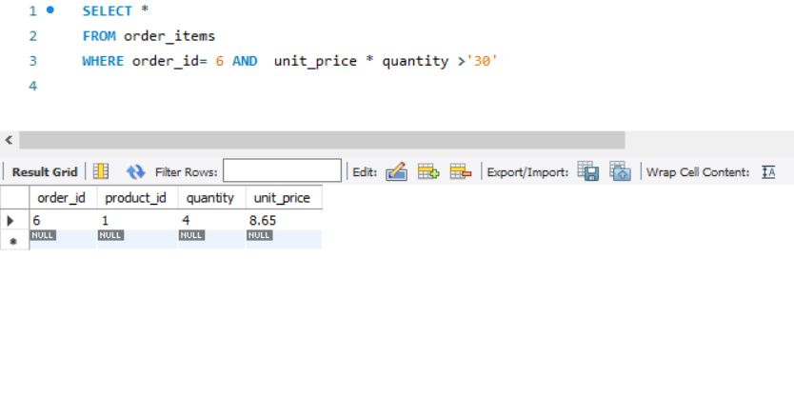

1. Return the products where quantity in stock is 49,38 and 72

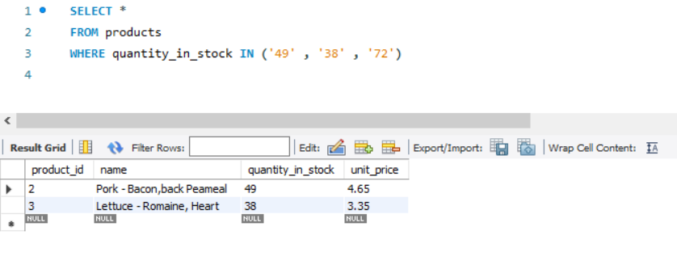

5.Return customers born between 01/01/1990 and 01/01/2000

